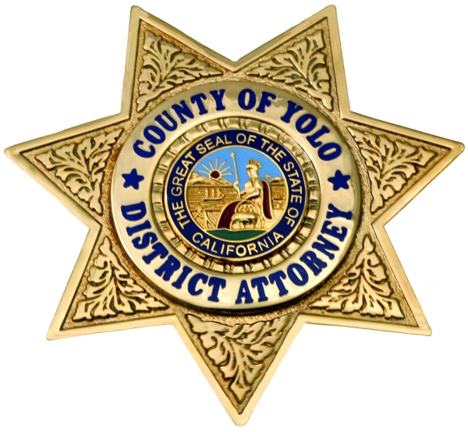
County of Yolo
Office of the District Attorney
Jeff W. Reisig, District Attorney
FOR IMMEDIATE RELEASE

Date: | September 26, 2018 | Contact: | DA Investigator Paul Hillegass
Paul.Hillegass@yolocounty.org
Bilingual Spanish Representative @ (530) 666-8356

Woodland Woman Convicted of Felony Workers’ Compensation Insurance Fraud

(Woodland, CA) – September 26, 2018 – On August 23, 2018, 43-year-old Rashimir Salazar, of Woodland, was sentenced by Judge David Rosenberg for committing workers’ compensation insurance fraud. Judge Rosenberg sentenced Salazar to 30 days county jail, two years felony probation and 40 hours of community service. Salazar had pled no contest On August 23, 2018 to one count of felony workers’ compensation insurance fraud. Salazar was also ordered to pay restitution in the amount of $9,820.86.

While working for Woodland Residential Services in February 2014, Salazar was injured while working. Salazar received $13,567.92 in temporary total disability (TTD) payments in lost wages due to the injury. It was discovered that Salazar was also working separately for a private customer while she was receiving TTD payments. Salazar intentionally withheld this information from the workers’ compensation insurance company in order to continue to receive TTD payments. This fraudulent conduct went unnoticed until the Special Investigations Unit (SIU) for CompWest Insurance started investigating the facts surrounding Salazar’s claim.

This case was investigated by the Yolo County District Attorney’s Workers’ Compensation Insurance Fraud Investigator and prosecuted by the Yolo County District Attorney Office. The Workers’ Compensation Insurance Fraud unit works to prevent and investigate claimant fraud, medical provider fraud, premium fraud, and uninsured employers throughout Colusa, Sutter, Yuba, and Yolo Counties. The most common type of workers’ compensation insurance fraud is claimant fraud, for which Salazar was convicted. Claimant fraud occurs when an employee lies or omits a material fact in order to obtain benefits that they would not have otherwise been entitled to. Examples would be to lie about how an injury occurred, the extent of their injury, or not to report outside employment and income.

Yolo County District Attorney Jeff Reisig believes in a fair marketplace. Through the efforts of this insurance fraud unit, investigations, like the one which resulted in this conviction, are conducted to identify, investigate, and prosecute offenders for workers’ compensation fraud.

While government resources are dedicated to determining fraudulent action, the public’s attention to this workers’ compensation fraud is important. To report workers’ compensation insurance fraud, call the DA’s hotline at 530-406-4524. Additional resources can be found at www.yoloda.org.

###

